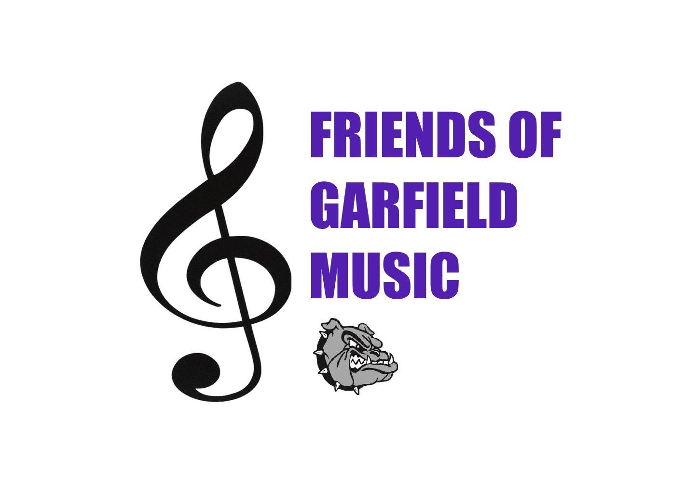
PROCUREMENT/DONATION FORM
2023-2024
PROCUREMENT DEADLINE: 1/05/2024
Please print using a dark pen.
Donor or Company name (as it should appear in
program):
Donor contact person (not listed in catalog): Donor’s telephone number:
Donor’s address: Donor’s email address:
Name of person soliciting donated item:
• Please send me invitations to Garfield Orchestra & Band events!

Detailed item description (quantity, size, color, restrictions, other information necessary to understand the item being donated):
Expiration date, if applicable: Signature (required): X
Tracking Number (Office Use Only):
Value of Donated Item: $ _____________._______

□ Cash donation enclosed. Checks payable to ‘Friends of Garfield Music’
□ I would like to sponsor a Garfield Orchestra & Band event. Please call me to discuss!
□ Donor to provide gift certificate □ To be delivered by donor
□ Donor to provide promotional material □ To be picked up by FOGM representative
PLEASE RETURN TO FRIENDS OF GARFIELD MUSIC
Garfield High School, P.O. Box 22749, Seattle, WA 98122-0749, President@garfieldorchestra.org
THANK YOU FOR YOUR DONATION TO FRIENDS OF GARFIELD MUSIC!
Your donation is tax deductible to the extent allowed by the law.
FOGO is a 501(c)3 non-profit corporation, EIN #91-1469442
PLEASE MAKE A COPY FOR YOUR RECORDS.

